INSTRUCTIONS TO WRITE CONTENT:

Prepare a content on the next page of this document, replacing the existing text and following the provided instructions.

Once you have completed the content, delete this first page, save the document as a Microsoft Word (.docx) file or an Open Document Format (.odt) file, and rename it using the surname of the corresponding first author.

Send your content to 24h-mom@olores.org before August 1, 2025.




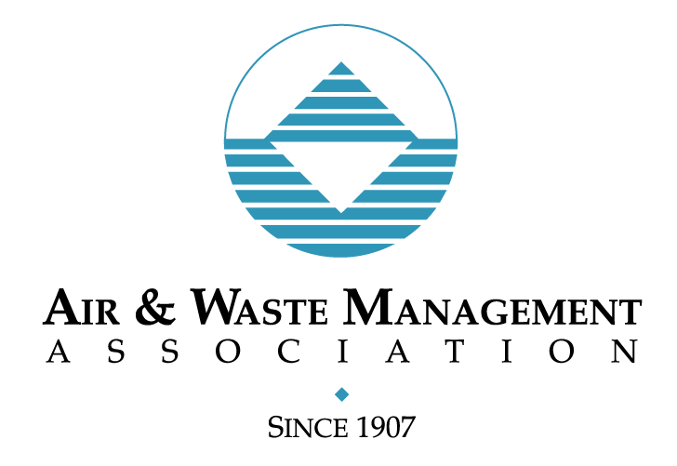





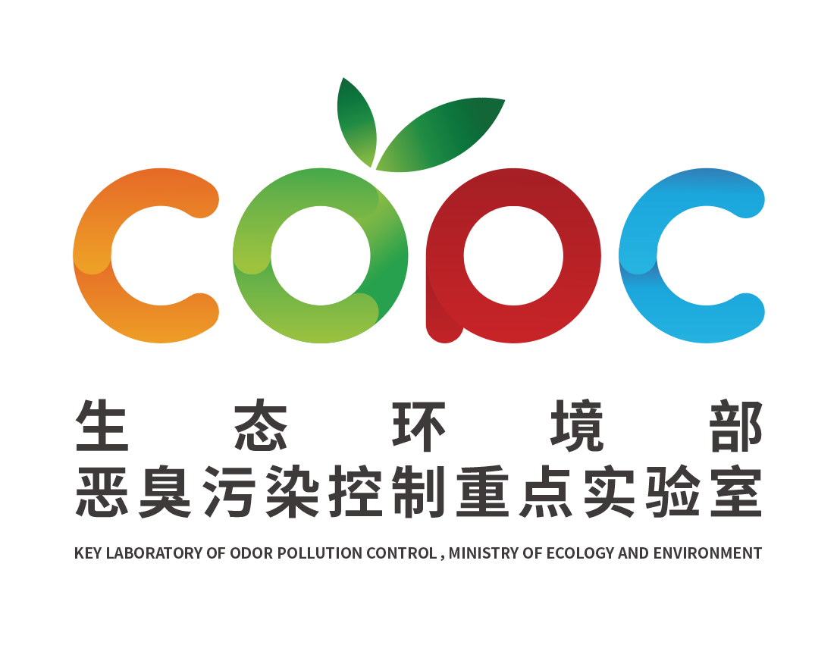


24-h Marathon on Odour/Odor Management (24h-MOM)

12 November 2025

CONTENT

TITLE (Arial 12, capitals and bold, single-spaced, centred/centered)

Authors and address (Arial 11 normal, single-spaced, justified)

E-mail of one of the authors and contact number (Arial 11 normal, single-spaced, justified)

Summary (800 words max (reference section not included), single-spaced, no indentation)

Provide details of the motivation and objectives; write a brief description of the work or experience, and state the conclusions.

Rest of the Content (no limitation of words, single-spaced, no indentation)

Indicate the topic of your work for the conference:

- Odour/Odor/VOC perception, impact and formation.
- Air dispersion and predictive modelling.
- Odour/Odor control technologies and emission reduction strategies
- Source characterisation and Odour/Odor/VOC mapping
- Policy, regulation, and compliance for Odour/Odor and air quality
- Community engagement, social media, and citizen action
- Odour/Odor from wastewater, sewer systems, livestock, and industry
- Corrosion management in wastewater systems
- Data analytics, big data, and artificial intelligence in Odour/Odor science
- Field assessment methods and electronic sensing
- Chemical forensics and source identification
- Best practices and case studies in Odour/Odor management
- Odour/odor and land use planning.
- Odour/odor generation.
- Other (suggest a new topic):

The contents will be reviewed by the following organiz/sations. Please select the organis/zation you would like to review your abstract based on your location:

Oceania
- Clean Air Society for Australia and New Zealand (CASANZ)
- Specialist Group on Odours of the International Water Association (IWA)

Asia
- Japan Association on Odor Environment (JAOE)
- Digital Olfaction Society (DOS)
- State Environmental Protection Key Laboratory of Odour Pollution Control (SEPKLOPC)
- Specialist Group on Odours of the International Water Association (IWA)

Europe
- Commission on Air Pollution Control Committee of the Association of German Engineers (VDI/DIN)
- International Society of Olfaction and Chemical Sensing (ISOCS)
- International Environmental Society of Odour Managers (AMIGO)
- Italian Society of Chemical Engineers (AIDIC)
- Specialist Group on Odours of the International Water Association (IWA)
- Digital Olfaction Society (DOS)
- Sensors Council Standards Committee (SC-SC) of the Institute of Electrical and Electronics Engineers (IEEE)

South and central America
- International Environmental Society of Odour Managers (AMIGO)

North America
- International Society of Olfaction and Chemical Sensing (ISOCS)
- Odor Technical Committee (TC) of the Air and Waste Management Association (A&WMA)
- Air Quality and Odor Control Committee (AQOC) of the Water Environmental Federation (WEF)
- Sensors Council Standards Committee (SC-SC) of the Institute of Electrical and Electronics Engineers (IEEE)

Are you member of any of these organiz/sations? Indicate which one: ____________

Send the abstract August 1st to: 24h-mom@olores.org

Please select only one. unless you are member of more than one organiz/sation.
Please note that members of the participating organiz/sations will have priority in the selection process.

